MDA512 — Data Science
Trimester 1, 2026 | Assignment 2
Predicting Bank Customer Churn Using Machine Learning:
Insights for the Australian Banking Sector

Submitted by:
Aravind Duggani (MIT251477)
Preethi Mothe (MIT252989)
Prasan Rana (MIT254245)
Rohan Thapa (MIT255815)
Rhiddhi Chakma (MIT251478)
Group / Tutorial:
Lecturer: Dr. Samar Shailendra
Submission Date: 26th May 2026
GitHub Repository:
https://github.com/aravindduggani1/mda512-churn-prediction
Use of Generative AI Tools:
Sections of this report were drafted and refined with the assistance of Claude AI (Anthropic) and ChatGPT (OpenAI).
- Anthropic, "Claude (claude-sonnet-4-6)," Anthropic, San Francisco, CA, USA. Accessed: May 2026. [Online].
- OpenAI, "ChatGPT (GPT-4)," OpenAI, San Francisco, CA, USA. Accessed: May 2026. [Online].

Table of Contents
1. Problem Statement and Background 3
2. Resources 4
3. Business Model 6
3.1 Research Questions 6
3.2 Challenges Encountered 6
3.3 Data Preprocessing and Wrangling 7
3.4 Algorithm Selection and Justification 7
3.5 Connecting the Dataset to the Research Questions 8
4. Data Analysis 8
4.1 Goals and Hypotheses 8
4.2 Tools and Libraries 8
4.3 Exploratory Data Analysis 9
4.4 High-Level Business Interpretation 12
5. Results and Recommendations 12
5.1 Model Performance Results 12
5.2 Key Drivers of Churn 14
5.3 Translating European Findings to the Australian Banking Context 15
5.4 Business Recommendations for Australian Banks 15
5.5 Conclusion and Future Work 15
References 16
Appendix A — Source Code Repository 17

1. Problem Statement and Background
The most urgent concern within today’s banks is focusing on customer churn, the loss of customers to competitors. Studies indicate that the costs associated with new customer acquisition are five to seven times greater than the costs associated with customer retention, underscoring the importance of customer retention for profitability and sustainable growth [1]. An expanding digital banking landscape, combined with evolving consumer preferences, has led to continued customer churn at an increasingly rapid, global scale, and has compounded the losses associated with customer lifetime value.
The reasons for customer churn are not straightforward and vary across regions and market segments. A bank with multiple market presences might find that customer churn for one market might not be the same for another. A “one-size-fits-all” retention policy will not work. The Australian banking market is such an example where the 2020 implementation of the Consumer Data Right (CDR) has allowed greater ease of bank switching for customers and has increased competition for the “Big Four” (Commonwealth Bank, Westpac, NAB, and ANZ) and newer digital competitors like Macquarie and ING Australia [2]. In spite of the tightening competition, many banks are still responding to customer churn with a policy where they react to customers’ decisions to leave, which leaves them with few options for customer retention [11].
Machine learning can transform traditional business practices from defence to offence. Tran, Le and Nguyen (2023) showed that classification techniques like Logistic Regression, Random Forest, and Support Vector Machines can spot future at-risk clients even if authors only include demographic and behavioural data. They achieve impressive predictive capacity without clients' transaction histories or private data. [11]. They provide evidence that the age, balance, activity, and number of accounts are the key predictors for absence in almost all banking databases.
Using their work as a springboard, this project deals with the churn problem and uses a real-world dataset of 10,000 bank customers from France, Germany, and Spain. It aims to not only build such a model, but also to describe empirically the reasons for customer churn and offer real-world based retention tactics for application in the Australian banking industry. In comparison to the prior literature, which focuses on predictive performance, this project focuses on business interpretability. In other words, the aim of the model is to give actionable insights to marketers, customer service representatives, and product designers [11]. At this research’s GitHub repository [3], a full implementation in Python with data preparation, initial data assessment, as well as model construction is presented.

2. Resources
The dataset used in this project is the publicly available Churn Modelling dataset hosted on Kaggle, a widely used repository for data science projects [4]. It contains records of 10,000 bank customers from three European countries — France, Germany, and Spain — and is structured as a single comma-separated values (CSV) file. The dataset is well-suited to this analysis as it combines demographic, financial, and behavioural attributes alongside a binary target variable indicating whether a customer has exited the bank.

Table 1: Attributes of churn modelling dataset, including datatypes and description for all 14 columns.
# | Attribute | Data Type | Description
1 | Row Number | Integer | Sequential row index (1-10,000)
2 | Customer Id | Integer | Unique customer identifier
3 | Surname | Text (object) | Customer's surname
4 | Credit Score | Integer | Customer's credit score (350-850)
5 | Geography | Categorical | Country of residence (France, Germany, Spain)
6 | Gender | Categorical | Customer's gender (Male, Female)
7 | Age | Integer | Customer's age in years
8 | Tenure | Integer | Number of years as a customer (0-10)
9 | Balance | Float | Account balance (in EUR)
10 | Num Of Products | Integer | Number of bank products held (1-4)
11 | Has Cr Card | Binary (0/1) | Whether the customer holds a credit card
12 | Is Active Member | Binary (0/1) | Whether the customer is an active member
13 | Estimated Salary | Float | Customer's estimated annual salary (in EUR)
14 | Exited (Target) | Binary (0/1) | 1 = customer left, 0 = customer stayed
The dataset contains 14 attributes split into 3 identifiers, 10 predictors, and the target variable (Exited). These attributes are summarised in Table 1. In the first step of the project, a preliminary analysis was done and confirmed that there are no empty cells or repeated rows [3]. This means the analysis can concentrate on engineering and modelling without considering imputation. Initial reviews of the target variable's class distribution showed that 20% is in the churned state and 80% is in the non-churned state. This is uneven and is addressed at the time of preprocessing and evaluation.

3. Business Model

3.1 Research Questions
The analysis is structured around five research questions that progress from broad behavioural patterns to concrete business applications:
- RQ1: What customer demographics and behaviours are most strongly associated with churn?
- RQ2: Does customer churn vary significantly by geography, and what does this imply for regional banking strategy?
- RQ3: Which machine learning algorithm provides the most accurate churn prediction — Logistic Regression, Random Forest, or Gradient Boosting?
- RQ4: Based on the identified churn drivers, what data-informed retention strategies should banks prioritise?
- RQ5: How can the insights from this analysis be applied to the Australian banking sector to reduce customer churn?

3.2 Challenges Encountered
There were multiple challenges when defining the framework for this project. Some of these challenges were proceeded with intentional choices of methods.
The first of these challenges was that of data. The datasets were scrutinized and compared to select the data most appropriate to the needs of the research. The dataset selected for this project was the Churn Modelling dataset available on Kaggle. This dataset has met the requirements of prior peer-reviewed research (concerning banking churn) [11].
The second challenge was selection of the model. As was initially intended, only one model was deployed. However, three models of increasing complexity were selected and deployed. These were Logistic Regression, Random Forest, and Gradient Boosting. Balanced performance of the model, when viewed from the perspective of either side of this equation (business or predictive) was the primary reason for this. Decision-makers would have limited utility for a model that was very accurate but one that could not be reliably interpreted [11].
The third and most problematic challenge was that of class imbalance. The ratio of churners to non-churners has been found to be approximately 20:80 in this dataset. A model that predicted "no churn" for every customer based on this dataset would nonetheless have a lofty accuracy of 80%. This accuracy is misleading, and, as evidenced by Tran et al. (2023), the performance of a model in imbalanced classification is better evaluated using ROC-AUC, Precision, Recall, and F1 Score [11].
Decisions concerning data processing represented the final challenge. These data processing decisions involved the selection of which columns should be retained or removed and what methods should be used to convert the categorical features (Geography and Gender) into numerical forms that could be processed by machine learning algorithms without introducing a spurious rank order.

3.3 Data Preprocessing and Wrangling
Step 3 of the project notebook [3] employed pandas and scikit-learn [5] for the purpose of data preprocessing. Three identifier columns were dropped (RowNumber, CustomerId, Surname) since they do not contribute to a predictive signal. To tackle the problem of multicollinearity for categorical features, one-hot encoding (pd.get_dummies with drop_first=True) was used. Stratified sampling preserved the original churn ratio of the dataset, and the data was split 80/20 into training and testing sets, respectively. To standardise numeric features, the StandardScaler was employed. It was fitted only to the training set to avoid data leakage. This provided suitable inputs for distance and coefficient-based models. Tran et al. (2023) used the same dataset and applied a similar preprocessing methodology [11].

3.4 Algorithm Selection and Justification
The selected algorithms span low, medium, and high complexity categories. The low complexity algorithm is Logistic Regression, which is a linear, simple to explain, and interpretable baseline [6]. The Random Forest algorithm is selected for medium complexity. It is an ensemble of multiple decision trees and can capture non-linear interactions [7]. Compared to Random Forest, Gradient Boosting, selected for high complexity, is also an ensemble, but a sequential one, and is known to have the best performance for tabular data [8]. It is suggested in literature regarding statistical learning to compare models of varying complexity to assess if there are significant gains in predictive performance when using more complex models [9]. Simultaneously, Tran et al. (2023) used the same data and found that ensemble methods always outperformed linear methods [11].

3.5 Connecting the Dataset to the Research Questions
Each research question is addressed at a specific stage of the analysis. RQ1 is answered through correlation analysis (Step 2) and feature importance scoring (Step 6); RQ2 is answered through the geography-based churn comparison (Step 2, Figure 2); RQ3 is answered through the model comparison (Steps 4–5); and RQ4–RQ5 are addressed through the interpretation of feature importance and the discussion of Australian application in Section 5. This structured mapping ensures every research question raised in Section 3.1 is directly traceable to an analytical output, satisfying the requirement for evidence-based business conclusions.

4. Data Analysis

4.1 Goals and Hypotheses
The analysis was based on the three testable hypotheses listed in Section 3, specifically regarding the research questions:
- H1: The geographic location of customers is associated with levels of customer churn.
- H2: Age and the activity status of users leverage significant behavioural insight when assessing the likelihood of churn.
- H3: Non-linear ensemble techniques will better serve predicting churn compared to linear models.
Hypotheses were explored through a combination of EDA and predictive modelling. Qualitatively, success was measured through visual representations of patterns. Quantitatively, success was measured through evaluation metrics of accuracy, precision, recall, F1 score, and ROC-AUC, with preference given to ROC-AUC given the dataset's class distribution imbalance.

4.2 Tools and Libraries
The analysis was conducted in Python within a Jupyter Notebook environment, hosted in the project's GitHub repository [3]. Five core libraries underpinned the workflow: pandas for data loading and manipulation, NumPy for numerical operations, matplotlib and seaborn for statistical visualisation, and scikit-learn [5] for preprocessing, model training, and evaluation. This stack is widely considered industry standard for tabular data science in Python. All code is reproducible and openly accessible via the project repository [3].

4.3 Exploratory Data Analysis
Five visualisations were produced to investigate the structure of the data and test the hypotheses, all generated in Step 2 of the project notebook [3].
Figure 1 — Target Distribution. A count plot of the Exited variable confirms a substantial class imbalance, with approximately 7,963 customers retained and 2,037 churned. This finding directly justified the use of stratified sampling during the train/test split and the prioritisation of ROC-AUC over raw accuracy as the primary evaluation metric.
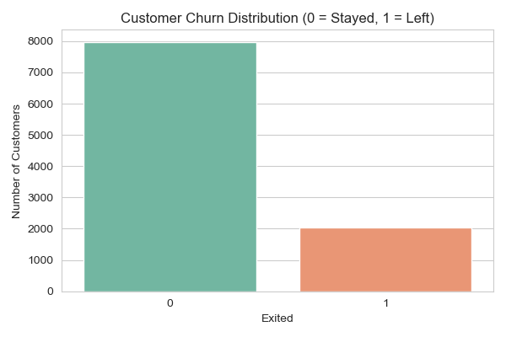
Figure 1: Distribution of the target variable Exited, illustrating the class imbalance with approximately 7,963 retained customers (80%) and 2,037 churned customers (20%).
Figure 2 — Churn by Geography. A grouped count plot of churn against Geography reveals a striking disparity: customers based in Germany churn at approximately 32%, almost double the rate observed in France and Spain (~16%). This visual evidence directly supports H1 and answers RQ2, suggesting that country-specific market dynamics play a meaningful role in retention.
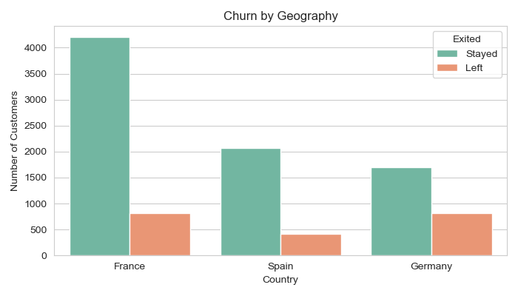
Figure 2: Customer churn distribution by country of residence, showing Germany's elevated churn rate (~32%) relative to France and Spain (~16% each).
Figure 3 — Churn by Gender. A similar grouped count plot for Gender indicates that female customers churn at a higher rate than male customers (~25% versus ~16%). This supports the gender component of H2.
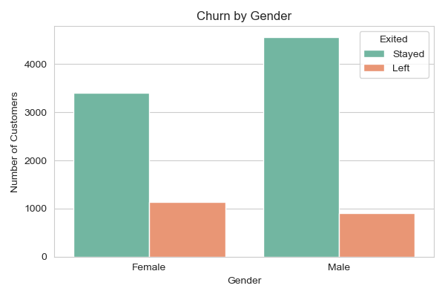
Figure 3: Customer churn distribution by gender, indicating a higher churn rate among female customers (~25%) compared to male customers (~16%).
Figure 4 — Age Distribution by Churn Status. Overlaying histograms with kernel density estimates for the two classes reveals that customers who churned are concentrated in the 40–60 age range, while retained customers cluster around 30–40. This is the single most informative visualisation in the EDA, providing strong visual support for the age component of H2.
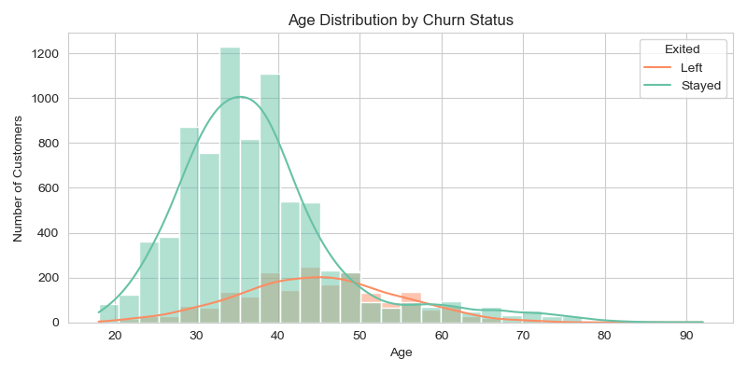
Figure 4: Age distribution of customers grouped by churn status, with overlaid kernel density estimates highlighting the 40–60 age range as the peak churn segment.
Figure 5 — Correlation Heatmap. A Pearson correlation matrix was computed across the numeric and encoded categorical features. Age shows the strongest positive correlation with churn (r = 0.29), while Is Active Member shows a moderate negative correlation (r = −0.16). The relatively weak linear correlations of other features hinted that non-linear models would be required to fully capture predictive patterns — directly motivating the algorithm selection in Section 3.4 and forming the basis for H3.
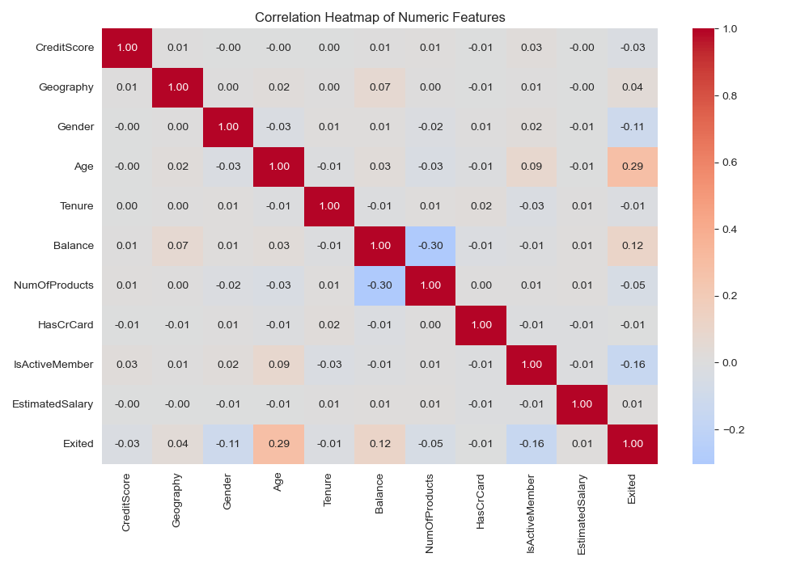
Figure 5: Pearson correlation heatmap of numeric and encoded categorical features, with Age showing the strongest positive correlation with churn (r = 0.29) and IsActiveMember the strongest negative correlation (r = −0.16).

4.4 High-Level Business Interpretation
The EDA shows three main findings. First, churn tends to concentrate in Germany. Second, customers over 40 show high potentiality of churn. Third, demonstrated engagement reduces churn. Based on these insights, Australian banks will need to implement churn strategies that have a region and a demographic focus. This finding is developed further in section 5.

5. Results and Recommendations

5.1 Model Performance Results
Each of the three models was evaluated on the metrics of accuracy, precision, recall, F1 score, and ROC-AUC using the held-out 20% test set of customers, which consisted of 2,000 records. With respect to these metrics, the best performing model was Gradient Boosting, with an F1 score of 0.60, a recall of 0.49 for churn, and a ROC-AUC of 0.87. The Random Forest model performed almost as well and was just slightly below that metric. The final model, Logistic Regression, achieved an impressive 81% accuracy, but had a recall of only 0.19 for churn, therefore, illustrating that accuracy is the wrong metric to focus on with imbalanced data. The confusion matrix (Figure 6) illustrates that 199 of the sample churn records were correctly identified by Gradient Boosting. These results were consistent with the findings by Tran et al. (2023) who demonstrated similar findings in their data set and reaffirmed the chosen methods and evaluations within this study [11].
Table 2: Comparative evaluation metrics across all three models
Model | Accuracy | Precision | Recall | F1-Score | ROC-AUC
Logistic Regression | 0.81 | 0.59 | 0.19 | 0.28 | 0.77
Random Forest | 0.86 | 0.78 | 0.46 | 0.58 | 0.85
Gradient Boosting | 0.87 | 0.79 | 0.49 | 0.60 | 0.87

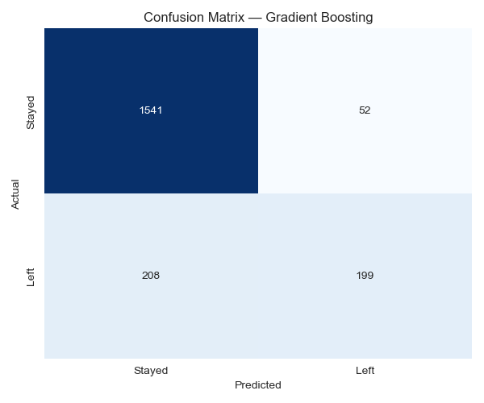
Figure 6: Confusion matrix of the Gradient Boosting model on the test set (n = 2,000), correctly identifying 199 of 407 actual churners.
The ROC curves (Figure 7) and metric comparison chart (Figure 8) visually confirm Gradient Boosting's superiority and validate H3 — that non-linear ensemble methods outperform linear models for this task.
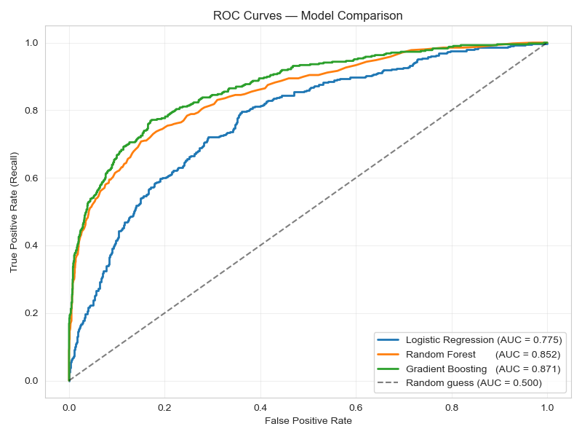
Figure 7: Receiver Operating Characteristic (ROC) curves for all three models, with Gradient Boosting achieving the highest area under the curve (AUC = 0.87).
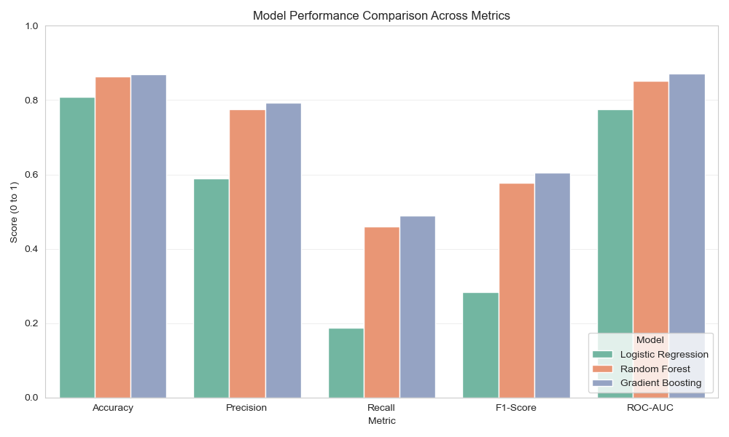
Figure 8: Comparative performance of all three models across five evaluation metrics — accuracy, precision, recall, F1-score, and ROC-AUC.

5.2 Key Drivers of Churn
Feature importance scores extracted from the Random Forest model (Figure 9) rank Age as the dominant predictor of churn (≈24%), followed by Estimated Salary, Balance, Credit Score, and Num of Products. This finding triangulates with the EDA: Age was the strongest correlate in the heatmap (r = 0.29) and the most visually striking variable in the histogram, confirming H2.
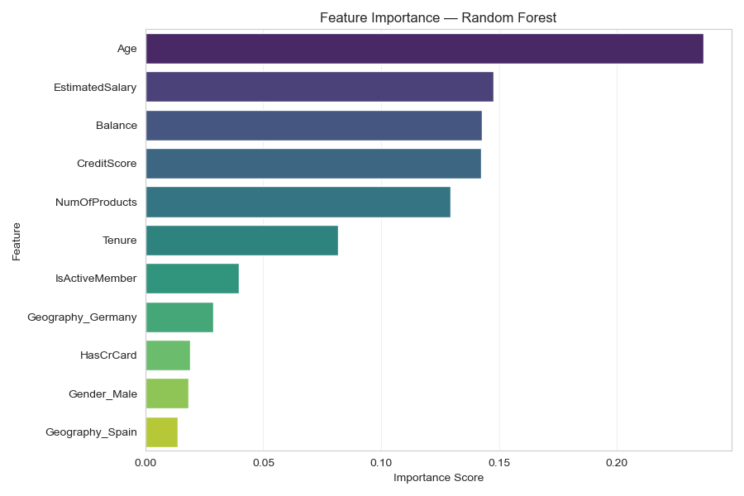
Figure 9: Feature importance scores from the Random Forest model, ranking Age as the dominant predictor of churn (≈24%), followed by financial and engagement features.
The geographic split observed in Figure 2 confirms H1, with Germany exhibiting nearly twice the churn rate of France and Spain.

5.3 Translating European Findings to the Australian Banking Context
Although the dataset originates from European banks, the patterns identified are demographic and behavioural rather than country specific. Australia's banking sector exhibits comparable age distributions, similar product portfolios, and equivalent churn dynamics across regional and metropolitan markets [2]. The findings are therefore transferable in principle, though precise magnitudes would differ. Future work should validate these patterns against Australian-specific datasets such as APRA's quarterly Authorised Deposit-taking Institution Performance Statistics [10].

5.4 Business Recommendations for Australian Banks
Five data-driven recommendations are proposed for the Australian banking sector:
- Targeted brand-awareness campaigns to ensure tailored offers reach the appropriate customer segments.
- Age-segmented cashback programs for customers aged 20–28, building long-term loyalty before they reach the high-risk demographic.
- Localised customer service investment in high-churn regions, mirroring the Germany pattern observed in our data.
- Strategic retail and health-sector partnerships (e.g., supermarket and pharmacy chains such as Chemist Warehouse) offering category-based discounts to the 40–60 age group, creating a win-win value model across bank, retailer, and customer.
- Flexible mortgage products designed for customers aged 40–60, leveraging Australia's strong home-ownership culture and government incentives (FHBG, FHSS) to create long-term product stickiness within the highest churn-risk demographic.

5.5 Conclusion and Future Work
This project demonstrated that machine learning can effectively identify at-risk bank customers and uncover the demographic drivers of churn. Among the techniques used, Age-based Gradient Boosting models was the most accurate and detected Age as the primary customer churn predictor. The methodology developed by Tran et al. (2023) established a validated baseline for this analysis. In the future, research can integrate the SMOTE rebalancing technique along with other explainable AI such as SHAP values to foster a balance between optimal model performance and transparency [11]. Other techniques can include implementation of XGBoost, neural networks, extensive hyperparameter tuning, and testing on Australian banking data.

References
[1] F. F. Reichheld and W. E. Sasser Jr., "Zero defections: Quality comes to services," Harvard Business Review, vol. 68, no. 5, pp. 105–111, 1990.
[2] Australian Competition and Consumer Commission, "Consumer Data Right (CDR) — Banking sector," 2020. [Online]. Available: https://www.cdr.gov.au/
[3] A. Duggani, "MDA512 Churn Prediction — Project Repository," GitHub, 2026. [Online]. Available: https://github.com/aravindduggani1/mda512-churn-prediction
[4] Kaggle, "Churn Modelling Dataset," Kaggle.com, 2018. [Online]. Available: https://www.kaggle.com/datasets/shrutimechlearn/churn-modelling
[5] F. Pedregosa et al., "Scikit-learn: Machine learning in Python," Journal of Machine Learning Research, vol. 12, pp. 2825–2830, 2011.
[6] D. W. Hosmer, S. Lemeshow, and R. X. Sturdivant, Applied Logistic Regression, 3rd ed. Hoboken, NJ, USA: Wiley, 2013.
[7] L. Breiman, "Random forests," Machine Learning, vol. 45, no. 1, pp. 5–32, 2001.
[8] J. H. Friedman, "Greedy function approximation: A gradient boosting machine," Annals of Statistics, vol. 29, no. 5, pp. 1189–1232, 2001.
[9] T. Hastie, R. Tibshirani, and J. Friedman, The Elements of Statistical Learning, 2nd ed. New York, NY, USA: Springer, 2009.
[10] Australian Prudential Regulation Authority, "Quarterly Authorised Deposit-taking Institution Performance Statistics," 2024. [Online]. Available: https://www.apra.gov.au/
[11] H. Tran, N. Le, and V.-H. Nguyen, "Customer Churn Prediction in the Banking Sector Using Machine Learning-Based Classification Models," Interdisciplinary Journal of Information, Knowledge, and Management, vol. 18, pp. 87–105, Feb. 2023. [Online]. Available: https://www.researchgate.net/publication/368911804

Appendix A — Source Code Repository
The complete Python source code for this project, including the Jupyter Notebook, dataset, generated figures, and supporting files, is publicly available on GitHub:
https://github.com/aravindduggani1/mda512-churn-prediction
The repository includes:
- notebooks/churn_analysis.ipynb — Full Jupyter Notebook with code, output, and visualisations
- data/Churn_Modelling.csv — The original dataset
- figures/ — All nine generated visualisations and result tables (CSV)
- requirements.txt — Python library dependencies
- README.md — Project overview and setup instructions
The notebook is structured into six logical steps that mirror the report sections: (1) data loading and exploration, (2) exploratory data analysis, (3) preprocessing, (4) model training, (5) model evaluation, and (6) feature importance analysis.

